

Last Update: September 21, 2017

Last Release: [Download Here](https://github.com/ichudakov/SCCommTools/releases)

ShipConstructor Community Tools

Contents

About ShipConstructor Community Tools 3

Disclosure of Risks and Liabilities 3

Ways for You to Contribute 3

Technical Summary 4

Installation Procedure 5

Step 1: Install the VBA Module for AutoCAD 5

Step 2: Ensure that Microsoft Excel 2010 or Later Version is Available 6

Step 3: Download and Unzip Archive with ShipConstructor Community Tools 6

Step 4: APPLOAD *.dvb and *.lsp Files into AutoCAD 6

Step 5: Load User Interface from Partial Customization File 7

Custom Commands for AutoCAD 9

General Commands 9

Import UCS List (CTIMPORTUCSLIST) 9

Rename UCS List (CTRENAMEUCSLIST) 9

Structure Commands 10

Lightening Hole (CTLIGHTHOLE) 10

Marine Drafting Commands 19

Group MarineDrafting Objects (CTMDGROUPOBJECTS) 19

Labeling Commands 21

Highlight Orphaned Labels (CTLABELHIGHLIGHTORPHANED) 21

Excel Tools 22

Linear Weight Distributions (CTWeightCalculations.xlsm) 22

# About ShipConstructor Community Tools

ShipConstructor Community Tools is an open-source non-profit initiative entirely driven by individual enthusiasts and owned by the Community as a whole. As a business entity, ShipConstructor Software Inc. (SSI) has no formal relationship with this project.

The sole purpose behind ShipConstructor Community Tools to promote innovation in the shipbuilding software development in an environment that promotes idea exploration, collaboration, sharing of knowledge and co-creation. All software code originating under this project is automatically licensed under an open-source licensing agreement in which the copyright holder provides the rights to study, change, and distribute the product to anyone and for any purpose, including possible commercial and non-commercial uses. All rights are granted free of charge and free of any conditions.

For more information on licensing, please refer to the LICENSE file included with each release.

# Disclosure of Risks and Liabilities

ShipConstructor Community Tools are created by enthusiasts who often perform work on their own time. In pursuing this activity, the enthusiasts may be driven by the desire to try new things ahead of the main product development, explore ideas and satisfy their intellectual curiosity. For this reason, features included with ShipConstructor Community Tools can be of highly experimental nature with not guaranteed correctness.

By using any materials that fall under ShipConstructor Community Tools, you do it at your own risk and assume the full responsibility for your actions. You will not hold any contributor(s) accountable and liable for any damages or losses sustained as a result of using ShipConstructor Community Tools.

You also agree not to hold ShipConstructor Software Inc. (SSI) liable for any damages and/or negative effects arising from your use of any materials obtained under ShipConstructor Community Tools.

For your information, some of the potential risks associated with using ShipConstructor Community Tools may include, but not limited to: corruption of your ShipConstructor project database beyond the state of repair, generation of incorrect production information resulting in significant financial losses to your company, discontinuation of Community Tools features without a prior warning, and zero guarantee that significant software defects are resolved in a timely manner.

# Ways for You to Contribute

There are several possible ways for you to contribute to the development of ShipConstructor Community Tools. If you possess sufficient programming skills, you are very welcome to request access to the GitHub project and write your own extensions for the Community Tools.

If coding in LISP and VBA is not something you are not your strongest assets, you can still provide significant value for this project simply by using the tools, sharing feedback and contributing ideas.

# Technical Summary

ShipConstructor Community Tools are comprised of the following:

* AutoCAD scripts written in LISP and VBA;
* AutoCAD partial customization file (*.cuix) that contains elements of user interface;
* Macro-enabled Excel documents; and
* General documentation.

Presently, the source code behind Community Tools commands does not rely on a direct communication with the ShipConstructor project database. The ShipConstructor API is not used either. As much as possible, all features are designed to rely on native AutoCAD commands and Microsoft Excel functionality alone.

The current philosophy behind ShipConstructor Community Tools is to only automate those operations that the user can, theoretically, perform manually inside an AutoCAD drawing or an Excel workbook. This approach is to provide an additional layer of safety by avoiding high-risk operations immediately affecting your project database. It is worth mentioning, however, that the above approach is still not a 100% guarantee that protects your project against unforeseen issues.

# Installation Procedure

The installation instructions for ShipConstructor Community Tools are fairly simple, but they may vary depending on your work environment. For the most part, the instructions described in this document are written for individual users who would like to install ShipConstructor Community Tools on their local workstations.

In case you are a CAD administrator who organizes work environment for multiple network users, your instructions may be slightly different. There will be a few recommendations provided for you in this section; however, because you are expected to have a higher level of familiarity with the CAD environment compared to an average user, some of the installation steps will be left up to your discretion to figure them out.

Note that most of the installation steps will only need to be repeated once. For later updates to ShipConstructor Community Tools, all you may be required to do is to replace some files and restart your AutoCAD.

## Step 1: Install the VBA Module for AutoCAD

First off, install the **VBA Module for AutoCAD**, unless you have already done it already.

The VBA Module for AutoCAD is necessary to run VBA scripts inside your AutoCAD application. It is an optional component that usually is not deployed with your AutoCAD by default, but can be downloaded from the Autodesk website at any time.

Different versions of AutoCAD require their own VBA Module.

To download the VBA Module for AutoCAD installer from the Autodesk website, you can try the link below:

<https://knowledge.autodesk.com/support/autocad/downloads/caas/downloads/content/download-the-microsoft-visual-basic-for-applications-module-vba.html>

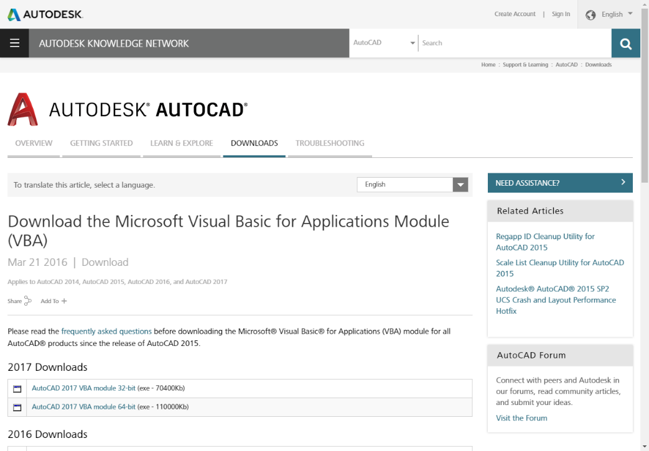

## Step 2: Ensure that Microsoft Excel 2010 or Later Version is Available

ShipConstructor Community Tools come with some macro-enabled Excel workbooks such as CTWeightCalculations.xlsm used for calculating weight distributions along your ship. If you plan on using the Excel components, please ensure that you have access to Microsoft Excel 2010, or a later version, installed on your computer.

In addition to having Microsoft Excel installed on your computer, you need to confirm that you have the permissions to enable VBA macros inside the application.

## Step 3: Download and Unzip Archive with ShipConstructor Community Tools

* Download the latest version of the ShipConstructor Community Tools archive from its network location. For the current location, please, see the link on the cover page at the very top of this User Manual.
* Unzip the files to a folder where they will be stored more or less permanently moving forward. Note that the folder can be created on the local hard drive of an individual workstation, or at some remote location.

If you are a CAD administrator who is organizing work of multiple users, you might, in fact, prefer to deploy the archive to a network location shared with multiple users.

Regardless of the location you choose, it will be best if the folder path is not likely to change. The reason is that there will be certain references created from AutoCAD to the Community Tools files in the very next step. In case you ever need to update ShipConstructor Community Tools with a newer version, your update procedure could be as simple as replacing a few files assuming the location remains the same.

## Step 4: APPLOAD *.dvb and *.lsp Files into AutoCAD

* Start your **AutoCAD**.
* Type **APPLOAD** in the AutoCAD command line.
* Under **Startup Suite**, click **Contents…**
* Add the two files, **SCCommTools.dvb** and **SCCommTools.lsp**, to the AutoCAD Startup Suite:

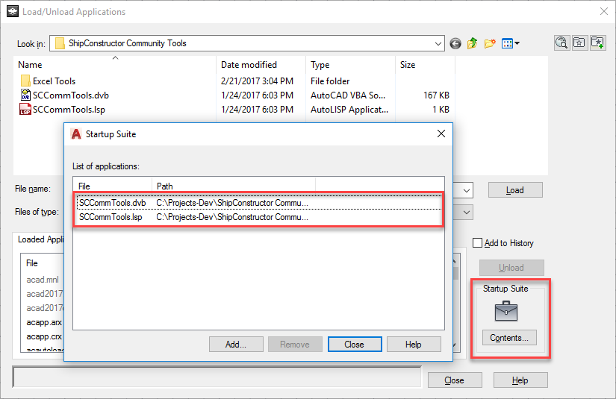

* Make sure all changes are applied and close all dialogs.

This action will ensure that custom commands that come with ShipConstructor Community Tools are loaded every time you launch your AutoCAD application.

Note that if you are a CAD administrator who is performing a set up for multiple users, you might want to keep the two files at a centralized network location so that it is easy to replace them in the future in case a newer version of Community Tools comes out.

## Step 5: Load User Interface from Partial Customization File

* Type the **CUI** command in the AutoCAD command line.
* Select **Partial Customization Files** in the upper half of the dialog.
* Right click the selection, and choose **Load partial customization file**:

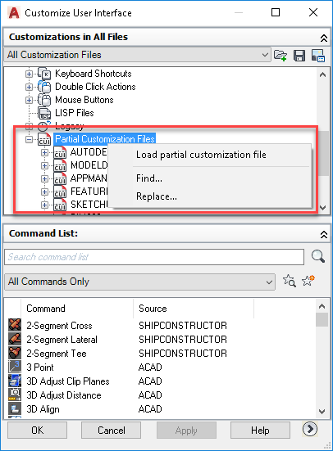

* Navigate to the **SCCommTools.cuix** file.
* Click **OK** to close the dialog.
* **Close** and **restart** AutoCAD.
* Notice the new **SC Community Tools** ribbon tab, menu and toolbar:

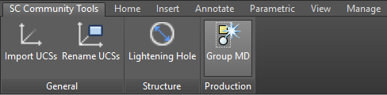

* Test if the commands are working.

# Custom Commands for AutoCAD

## General Commands

### Import UCS List (CTIMPORTUCSLIST)

The **CTIMPORTUCSLIST** command imports all User Coordinate Systems (UCS) from an external *.dwg file into the current drawing. If a similarly named UCS already exists in the current drawing, the import for that UCS will be skipped.

### Rename UCS List (CTRENAMEUCSLIST)

The **CTRENAMEUCSLIST** command does batch-renaming for UCS that reside in the current drawing. Caution should be exercised when using this command as it might significantly change names of multiple UCSs. Restoring the names back to their original state may not be easy. To perform the renaming:

* Run the CTRENAMEUCSLIST command;
* Enter the sequence of characters to be replaced in each UCS’s name;
* Enter a new sequence of characters with which to replace the previous sequence;
* Complete the operation.

## Structure Commands

### Lightening Hole (CTLIGHTHOLE)

The **CTLIGHTHOLE** command produces reference geometry such as rounded rectangles represented by closed AutoCAD polylines that can be used for creating some types of lightening holes. The command can be configured to place its output on the **_Draft_Cut** layer, or any other layer of choice. To create an actual lightening hole, the **SCADDOBJECTTOSTRUCTPART** command will need to run on the reference geometry.

#### Parameters

Lightening holes are created based on realistic engineering principles dealing with structural strength and integrity. Most the control parameters are defined relative to the surrounding structure. Where applicable and as applicable, the definitions are consistent with common Lloyd's and ABS rules.

The actual values for the parameters can be adjusted by the user to meet the specific requirements for a particular type of vessel. For example, smaller lightening holes may be preferred for navy vessels while large ones may be more suitable for racing yachts.

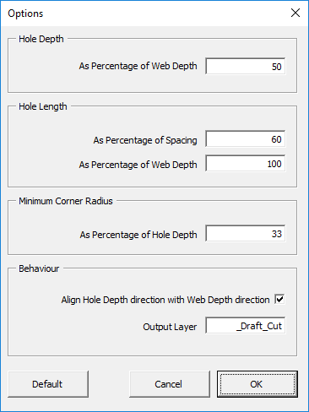

#### Sample Workflow

There are several possible ways to use the **Lightening Hole** command. As one quick example of using the functionality:

* Locate a structural web in your drawing and identify its depth and available spacing.

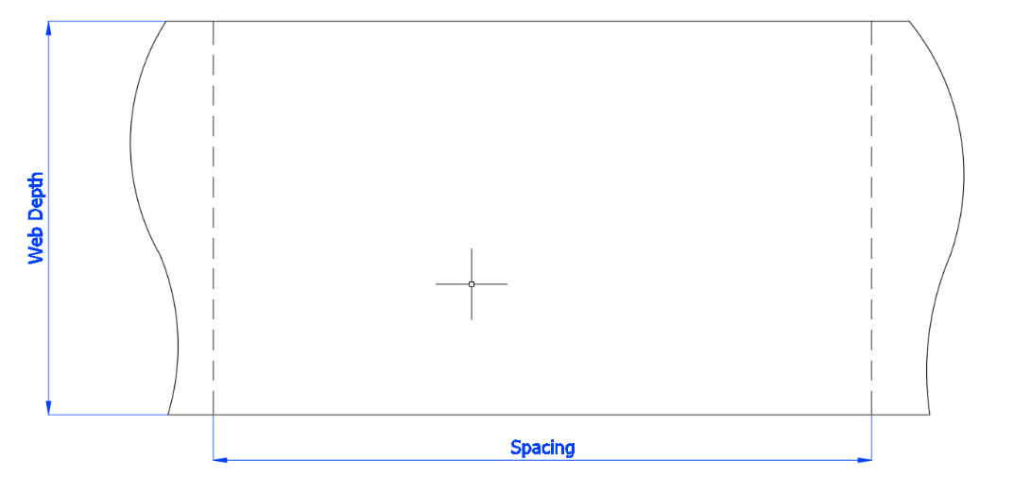

* Run the **CTLIGHTHOLE** command.
* Select the **Draw** option:

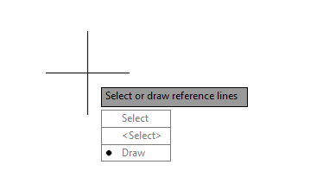

* Select two points on the opposite edges of the web to draw the first reference line measuring the web depth. Note that the reference line does not need to be ideally vertical:

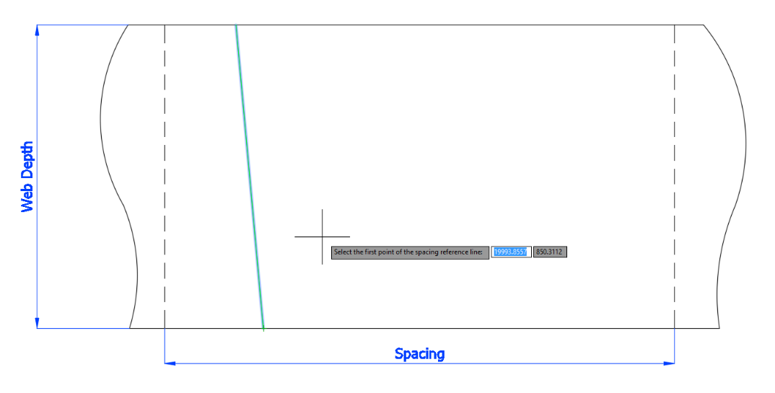

* Select the next two points to draw the second reference lines to indicate the spacing available. Note that the reference line does not need to be ideally horizontal:

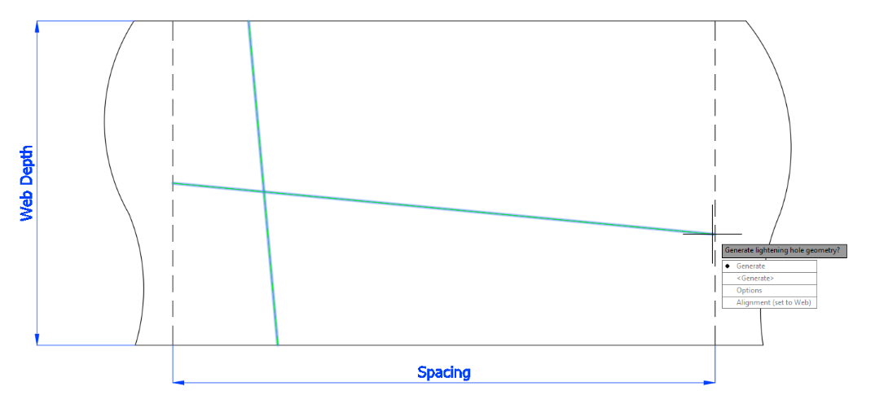

* Ensure that the **Alignment** parameter is **set to UCS**. This will guarantee that the hole is rotated consistently with the current UCS’s axes directions.
* Notice that you can change the **Alignment** at any time if necessary, but don’t do it now:

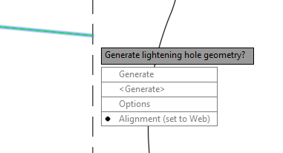

* Choose **Options** and review other parameters controlling the geometry. Notice the **Output Layer** for the resulting polyline:

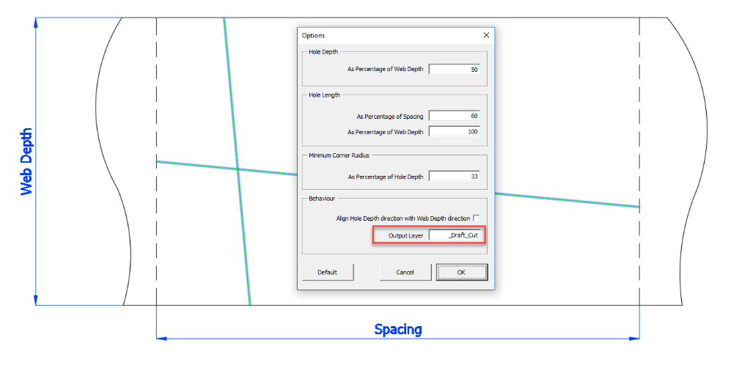

* Click **OK** to close the Options dialog.
* Use **Generate** to create the closed polyline representing the lightening hole:

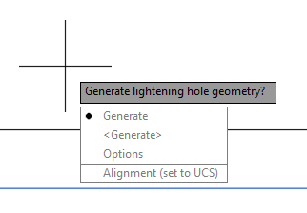

* **Delete** the reference lines unless you need to keep them for some reason:

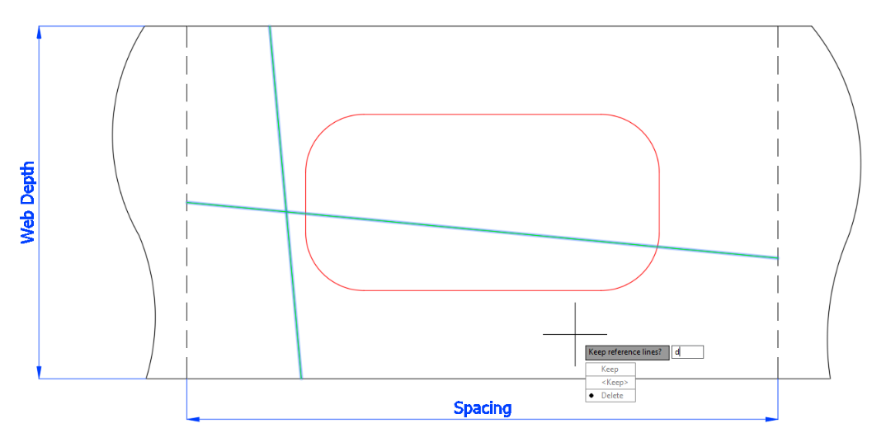

* Once the operation is complete, the final result may appear as follows:

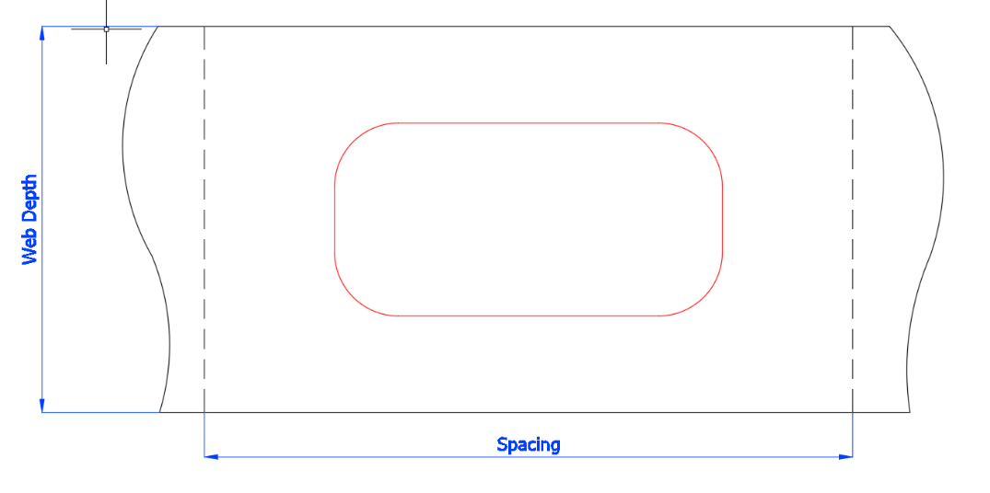

* If you dimension the final output, you may be able to see the following:

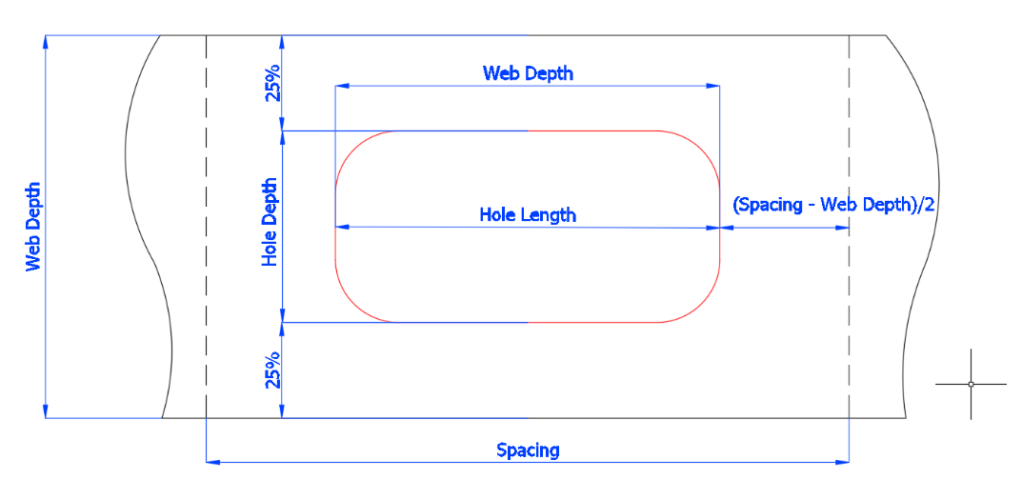

* + The hole is positioned in the middle of the structural web and centered relative to the available spacing;
  + The hole is oriented parallel to the axes of the current UCS;
  + The hole depth is the percentage of the total web depth specified in the command options;
  + The hole length equals to the lesser of the two: 1) the web depth, or 2) the percentage of the spacing distance set in the command options; and
  + The corner radius for the hole is a percentage of the hole depth as per command options. Note that the radius can be increased up to 50% to make the hole even more rounded.

#### Other Ways to Use the Command

In the previous example, we drew the two reference lines measuring the web and spacing distance. Sometimes, you may have such lines created ahead of time. If this happens to be the case, you can simply select the lines either before or after running the **SCLIGHTHOLE** command.

Note that Web Depth line needs to be selected first and then, the spacing line:

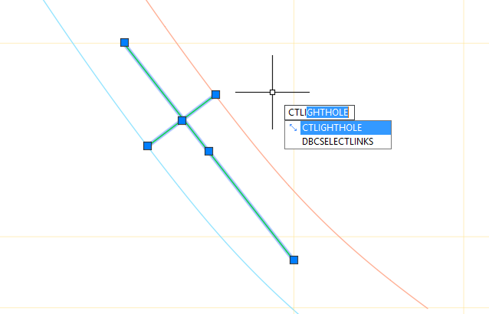

The **Alignment** parameter can be changed so that the hole is aligned relative to the web-depth line instead of the current UCS:

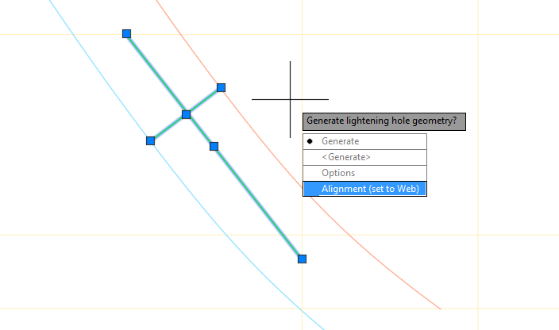

This option can be handy when placing lightening holes at an angle:

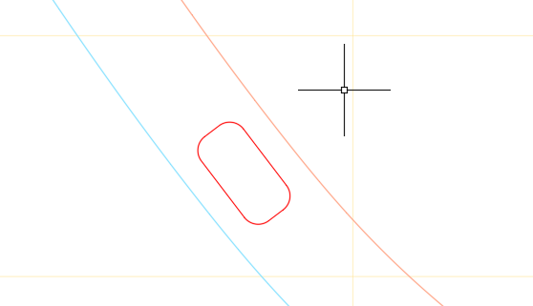

Finally, multiple lightening holes can be created in a batch operation. All you need to do is to select multiple pairs of reference lines as an input to the command. Remember that for each pair of lines, the web depth line needs to be selected first:

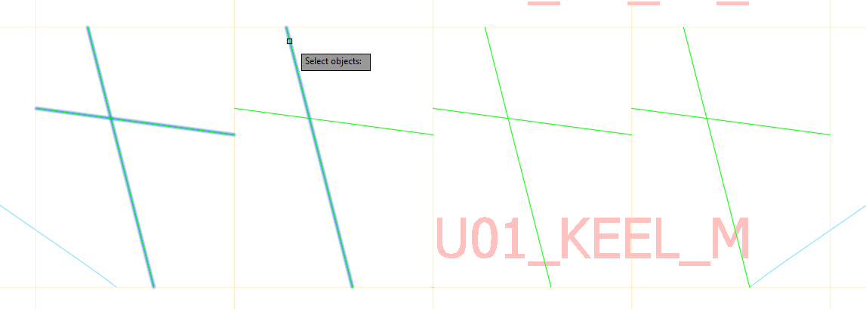

After all pairs of reference lines are selected in the correct order, running **Generate** will produce multiple polylines:

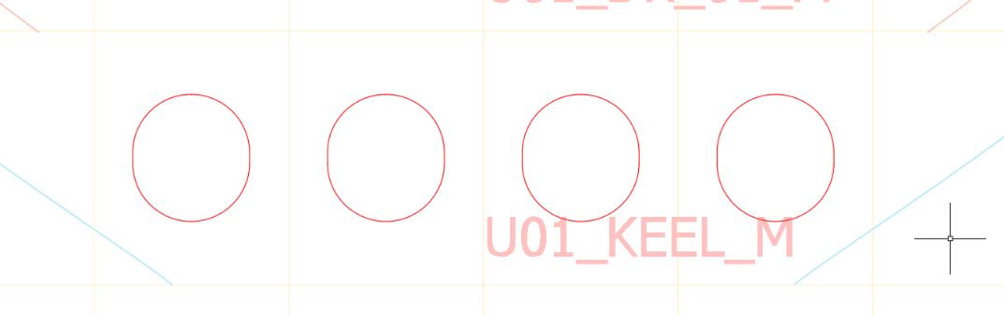

## Marine Drafting Commands

### Group MarineDrafting Objects (CTMDGROUPOBJECTS)

This command is for application inside MarineDrafting views containing 2D representations of the 3D model. The command joins isolated bits and pieces of the MarineDrafting geometry into AutoCAD Groups.

Currently, there are two options that control the consolidating behaviour:

* **Forming AutoCAD Groups by Part** – all bits and pieces of the geometry that belong to the same part become one AutoCAD Group;
* **Forming AutoCAD Groups by Part and Layer** – all bits and pieces of the geometry that belong to the same part and reside on the same layer become one AutoCAD group.

The benefit of having related 2D geometry consolidated into groups is that it makes performing certain operations much faster and easier. For example, if you decide to delete an entire part from the 2D view, you can do it in one step by deleting the AutoCAD group that joins all bits and pieces of the geometry for that part together. There will be no need to click every single bit of geometry one by one to remove the part. The same applies when you need to remove invisible portions of a part from the drawing. In this case, you can apply grouping by part and by layer and then, simply delete all groups that consolidate geometry on invisible layers.

To use the command:

* Open a MarineDrafting drawing.
* Run **CTMDGROUPOBJECTS**.
* Select all or some MarineDrafting views. If you are selecting some of the views only, please ensure that you click on any geometric object inside that view.
* Choose the method for grouping objects:

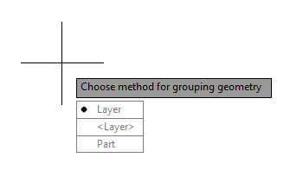

* Complete the command.

Note that after the command has finished, all items affected by the grouping command will be become modified elements in terms of MarineDrafting. There will be some changes in the update behavior for the affected parts. Also all affected geometry will be copied to the invisible **SCMD Original** layer. More information on the behaviour of modified parts in MarineDrafting views is available from the ShipConstructor product manual.

To release all groups in the drawing:

* Run the **CTMDGROUPOBJECTS** command.
* Select **More…**
* Choose **Reset All Groups in Drawing**.

All groups in all MarineDrafting views will be released.

## Labeling Commands

### Highlight Orphaned Labels (CTLABELHIGHLIGHTORPHANED)

The command *highlights* all “orphaned” labels that have lost their association with the original BOM table on the current layout. Such labels may happen as a result of the user copying (CTRL+C) and pasting (CTRL+V) labels in a production drawing, which is not a recommended ShipConstructor workflow for labels.

The danger of having orphaned labels in your drawing is that they don’t update properly and can be easily mistaken for legitimate labels:

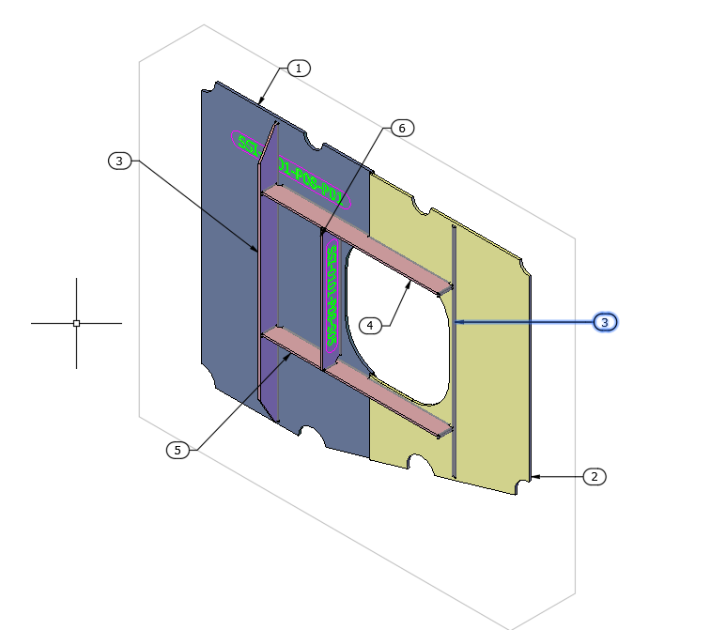

# Excel Tools

## Linear Weight Distributions (CTWeightCalculations.xlsm)

The **CTWeightCalculations.xlsm** macro-enabled Excel document included with ShipConstructor Community Tools allows you to quickly produce linear weight distributions for your ship along the longitudinal, transverse or vertical directions.

Recommended Workflow

The recommended workflow for using the tool as follows:

* For all parts that participate in the weight model, extract your initial data from ShipConstructor or other sources and save it inside a separate Excel file. It does not matter as much what tools you use, or how exactly you create the source document. What matters most, however, is the presence of the required set of ten columns inside the spreadsheet. For each, part that participate in the weight model you must provide the following columns:
  + Weight
  + Longitudinal Coordinate for Center of Gravity (LCG)
  + Transverse Coordinate for Center of Gravity (LCG)
  + Vertical Coordinate for Center of Gravity (LCG)
  + Longitudinal Coordinate for Minimum Extent
  + Transverse Coordinate for Minimum Extent
  + Vertical Coordinate for Minimum Extent
  + Longitudinal Coordinate for Maximum Extent
  + Transverse Coordinate for Maximum Extent
  + Vertical Coordinate for Maximum Extent

For example, the below illustration shows an Excel spreadsheet generated with **PublisherLT** that contains all of the required data, plus some additional columns:

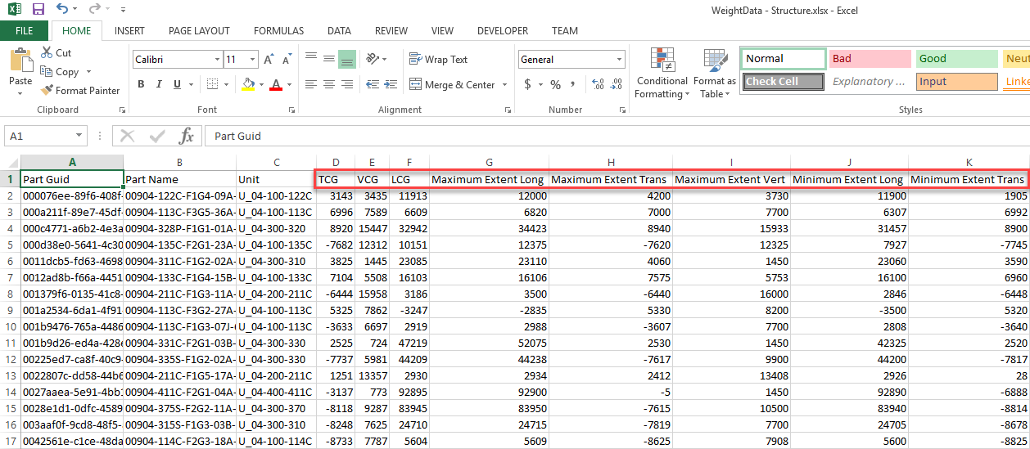

Note that the same document could have been produced with the help of ShipConstructor Reports, a direct Microsoft Excel query into the ShipConstructor database or by filling out each piece of data manually.

Also note that your ShipConstructor project database may not be the only available source of information. Some data may be added from your ERP system or other Excel documents. Generally speaking, it does not matter where the information is coming from as long as you can provide the minimum required set of parameters for each part.

* When developing your source Excel spreadsheet with weight data, note that the **Weight** attribute can mean different things. For instance, it can be the dry weight, wet weight, fluid weight, total weight or some other weight. The important part is to keep all weight information consistent across items in the dataset.
* Besides the key set of required columns, some additional attributes you may include into your source spreadsheet can be any descriptive properties such as Part Name, Stock Name, Stock Description and more.

The benefit of having this additional information inside the spreadsheet is that it helps you to search for and recognize individual parts in the dataset.

* The source data you provide may be stored on multiple sheets inside a single Microsoft Excel document, or it can be broken down into several Excel workbooks.
* When working with multiple spreadsheets, it is important to keep names of all columns identical across all sheets and workbooks you supply. Please, make sure that the text recorded in the very top cell of each column is the same for all columns containing similar type of data.

Note that the exact wording you may use in column headers is not that important. It is the consistency that matters. For instance, you can choose to name your Weight column such as “Weight”, “Weight (kg)”, “W.” or something else. As long as that text does not change across similar columns located on different spreadsheets, the tool will work.

Also note that locations of individual columns inside your source spreadsheets are not important either. The Weight column may appear in the first position inside one table and the third position in another. It is the column headers that carry the primary importance. CTWeightCalculations.xlsm will rely on the headers to search for the right data on each sheet.

* After your source data sheet(s) is compiled, open the **CTWeightCalculations.xlsm** in Microsoft Excel.
* Ensure that macros are enabled. In later versions of Microsoft Excel, the macro settings can be located under: File > Options > Trust Center > Trust Center Settings > Macro Settings.
* Go to the custom **CT WEIGHT** tab on the ribbon and click the **Headers** button:

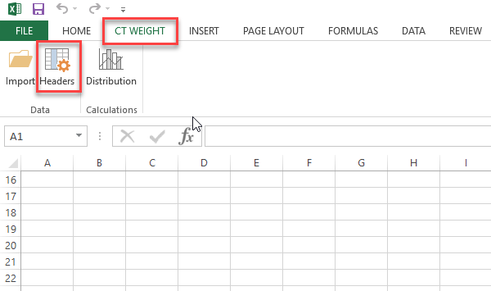

* You will see the complete list of columns that the CTWeightCalculations.xlsm will attempt to import from your source documents. The columns are listed in the same order in which they should appear at the destination location after the data is transferred.
* You can adjust and rename the headers as required. Basically, you specify which column to search for and transfer from your source location, and how to name these columns after moving the data to your destination location, which is CTWeightCalculations.xlsm. You can see it as a column mapping procedure:

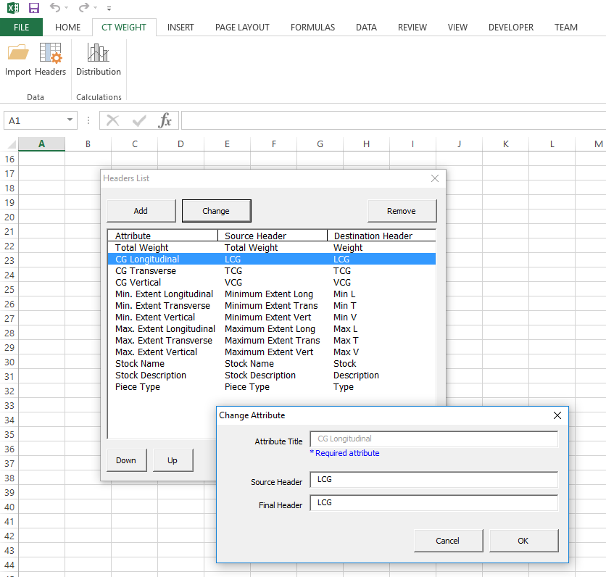

* Besides setting up the headers, you can also change the relative order in which columns should appear in your destination document, CTWeightCalculations.xlsm.

One requirement, however, is that the relative order in which columns appear inside CTWeightCalculations.xlsm should be set prior to importing your first set of data into this document.

* Finally, you can also add and remove some columns as need be. The only columns you cannot remove are the required attributes.
* After all headers and columns are set up, close the **Headers List** dialog.
* Click the **Import** button located next to the **Headers** button.
* Navigate to your source Excel file and select the specific sheet from which the data is to be transferred. Indicate where to put this data inside CTWeightCalculations.xlsm:

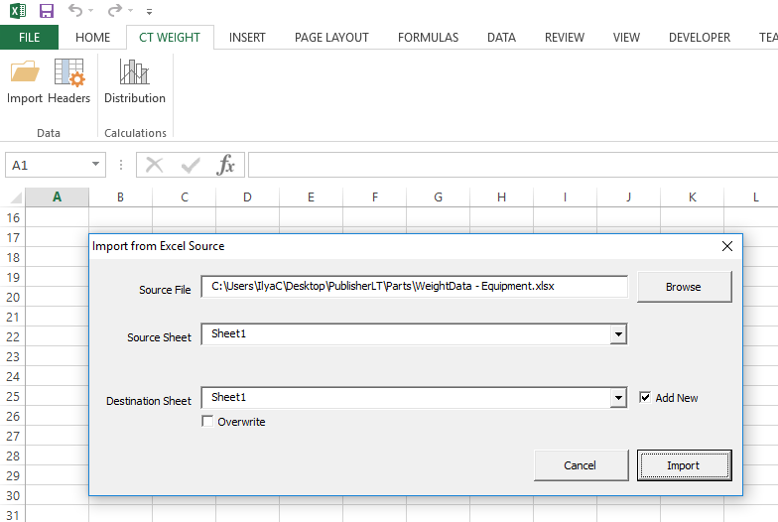

* Click the **Import** button to continue.
* The information will be transferred from your source spreadsheet to CTWeightCalculations.xlsm.

You can think of it as a refined sub-selection from your source dataset. The spreadsheet at the destination location will only contain columns that you requested in the headers list:

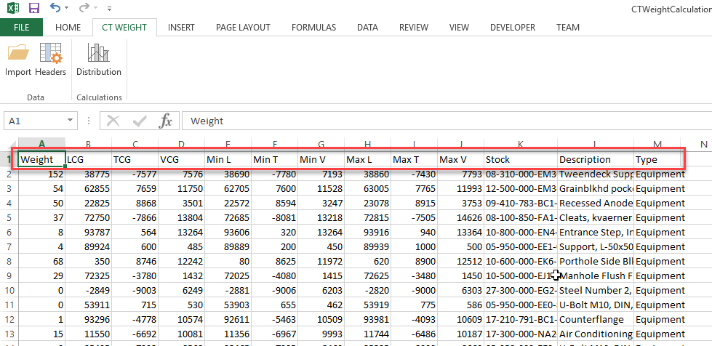

* You can repeat the Import operation as many times as necessary while bringing in more datasets and placing them on separate sheets inside CTWeightCalculations.xlsm.

One practical reason for why you may need to import several datasets and store them on separate sheets may be that you are looking to generate different weight curves for Structure, Equipment, Piping and other sections of the ship. You can organize worksheets so that each tab contains parts of one discipline only:

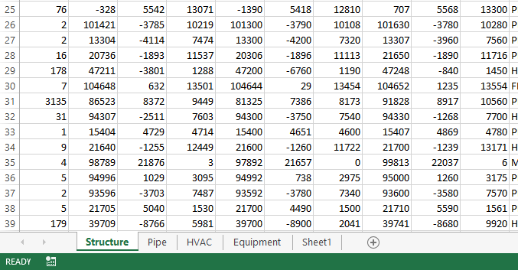

* Overall, there may be many different reasons for working with a few isolated datasets.
* In some cases, it might be beneficial to add certain sheets manually to CTWeightCalculations.xlsm. For example, you may be looking to enter manual corrections for your weights model to account for parts not represented in ShipConstructor. Or you may be looking to explore various scenarios such as loaded vs. unloaded ship.

When creating sheets manually inside CTWeightCalculations.xlsm, please ensure that you arrange columns in the correct order as specified in the Headers List dialog.

* Once all “refined datasets” are inside CTWeightCalculations.xlsm, click the **Distribution** button located on the ribbon:

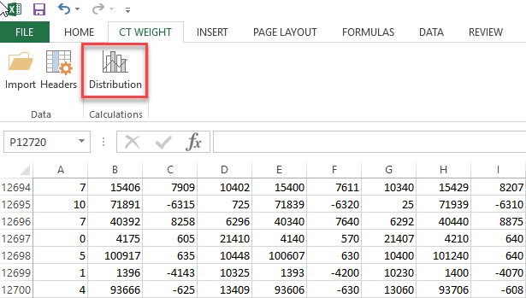

* In the **Weight Distribution** dialog, set the desired parameters for the distribution:

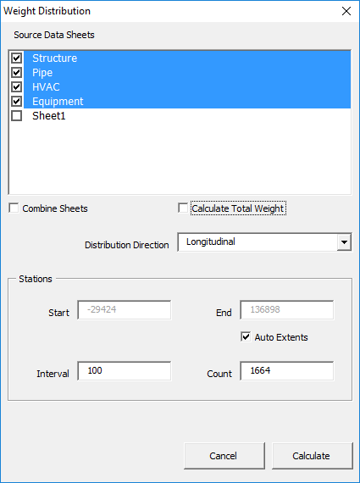

Note that you can pick and choose which individual sheets to factor into the calculation. You may choose to combine all tables into one or treat them as separate datasets. There is an option to include an extra column with Total Weight showing the sum of all weights across all datasets. You can change the distribution direction from Longitudinal to Transverse or Vertical. Finally, there is a number of options to assist you with placing station points along the distribution.

* After you click the **Calculate** button, a separate unsaved Excel document will be created showing containing the distribution. The new workbook will have two sheets: one with the chart and one with the underlying data:

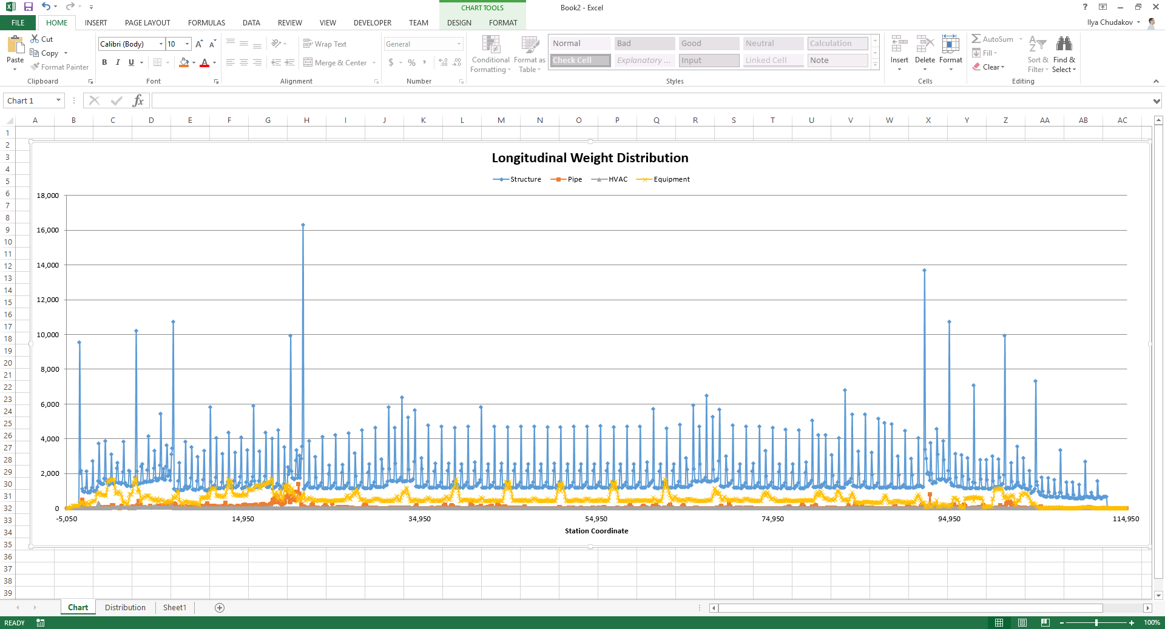

Method for Calculating Weight Distribution Curves

According to the calculation method used by CTWeightCalculations.xlsm, each weight distribution curve and its associated data represents a linear weight density function along the chosen direction. For each station point, the function tells you the weight for the section of the ship locked in between the current station point and the next one.

The data is presented in absolute units corresponding to the specific length of the interval set between the station points. The figures are not converted into standard units such as tonnes per meter of length. Note that longer intervals will generally result in higher weights per section because the length of each section increases.

It is important to mention that all weight-distribution calculations are not precise. All figures are approximate. For each individual part, the tool is only capable of making its best guess about the weight contribution by a given part at a particular section of the ship. All of the approximations are derived from a very limited information about the part such as its weight, geometric extents and the center of gravity location.

The way the weight density function is calculated for the individual part along the distribution direction is explained in the illustration below:

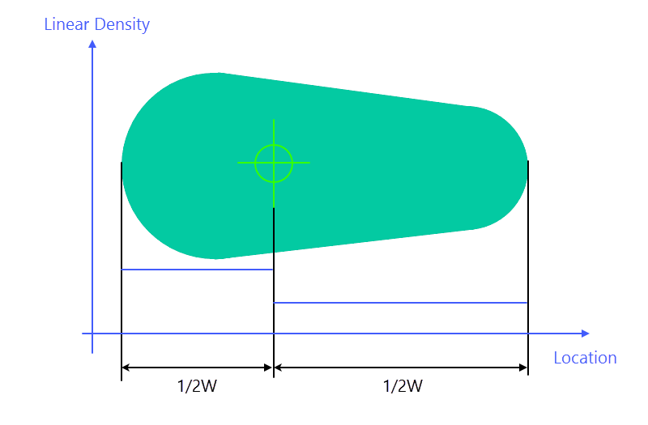

Each part is subdivided at its center of gravity (CG) into two portions assigned with 50% of weight. Then, the 50% of the weight are averaged for each portion of the part between the closest extent and the CG location. For non-uniform parts with an asymmetric center of gravity, their individual weight density function will appear as a step function as shown by the blue line in the illustration above.

By knowing the linear weight density function for each individual part and the overlap between the part and the current section of the ship, necessary calculations are made to measure the contribution of that part into the section weight.

Ability to Fix Some Parts

The weight-distribution calculation algorithm has the capacity to fix individual parts with the center of gravity location that is apparently incorrect.

To provide some background on this subject: in ShipConstructor, it is the responsibility of the user to indicate the correct CG location for some part types such as Equipment. Due to the human factor, sometimes, the CG location for Equipment parts may not be specified accurately. There may be other part times similar to equipment in this regard.

If the algorithm identifies a part with the CG lying completely outside of the part’s extents, or directly on one of the faces, the algorithm automatically reposition the CG point so that it lies exactly in the middle of the part. The weight of the part will be averaged along its length defined by extents.